Module 1: Remote Sensing Project Planning and Documentation
Project planning and methods documentation play a key role in any remote sensing analysis project. This module is designed to encourage workshop participants to think through their remote sensing approach to ensure the resulting products will be relevant to their needs and that the chosen methods are well documented and transparent.
- Project Planning Information
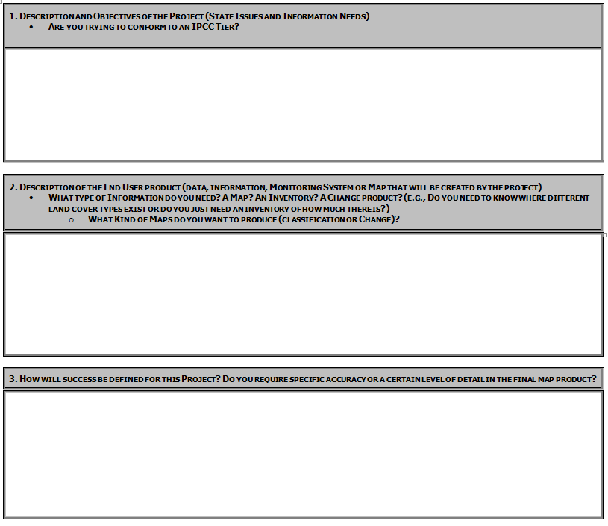
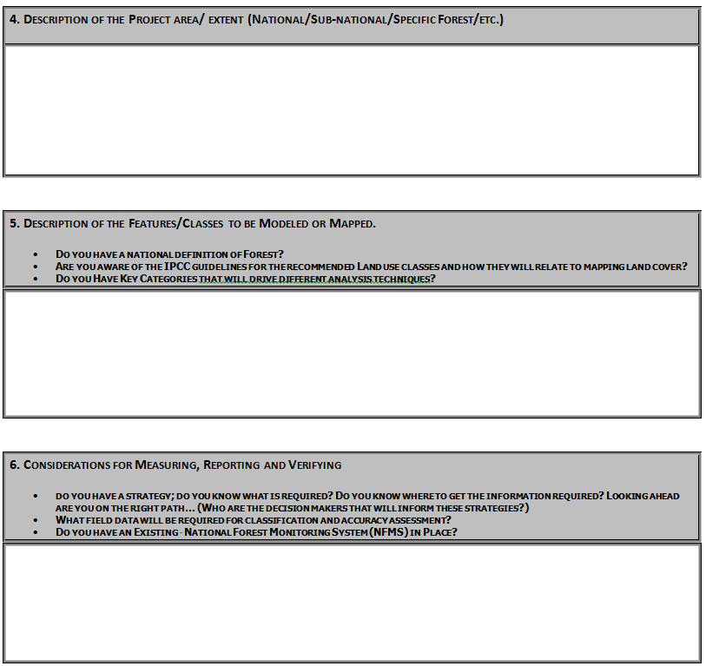

- Documentation, Archiving and Reporting Worksheet
This worksheet is designed to assist participants with becoming more efficient and informed about documenting and archiving information relating to the planning, preparation, and management of remote sensing datasets and analysis conducted for forest inventory monitoring associated with REDD+ activities. Documentation and archiving remote sensing analysis methods ensures there is transparency and makes it easier to replicate or improve methods as programs increase in complexity and robustness. For more information on the good practice recommendations for documentation, archiving and reporting please refer to the 2006 IPCC Guidelines Vol. 1 Chp 6 Section 11.

Analysis Outline
Below we have provided you with headings and some queues on where you should provide information about the workshop processing workflow to ensure transparency about the data and processing steps taken to comply with the good practice recommendations discussed above. The idea is that the information you provide below should be sufficient and clear enough so that an individual other than you can understand how the analysis was conducted and would be able to replicate it. Take the time to customize and add additional sections to this document. This exercise is designed to get you started in this practice and moving down the right path.

Processing Steps:

Preparing and Downloading Cloud-free Composite Using Google Earth
Data Used:

Time frame for composite:

Software Used:

Preprocessing Methods:

Methods for cloud removal:

Assess RS results:

Assumptions:

Note: Need to archive outputs before proceeding with analysis.

Creating Band Ratios, Indices and Image Transformations for use in Classification and Change Detection Analysis
Software Used:

Description of Indices:

Assess RS results:

Assumptions:

Note: Need to archive outputs before proceeding with analysis.

Image Classification Scheme
Document Clear definitions for classes or categories (i.e., land use categories defined by the IPCC as: Forest Land, Cropland, Grassland, Wetlands, Settlements, and Other Land):

Have you identified any categories as “Key Categories”? How is the analysis different? Please refer to Volume 1, Chapter 4 of the 2006 IPCC Guidelines on what defines a “Key Category”.

Assess RS results:

Document assumptions:

Note: Need to archive outputs before proceeding with analysis.

Collect Reference Data
What type of reference data are you using?

What is your sampling scheme and what is the logic for its design?

Assess RS results:

Document assumptions:

Note: Need to archive outputs before proceeding with analysis.

Perform Land Cover Classification or Land Cover Change Analysis
Software:

Analysis Technique:

Assess RS results:

Assumptions:

Note: Need to archive outputs before proceeding to next steps.

Perform Accuracy Assessment
Sampling Approach:

Analysis Technique:

Assess results:

Assumptions:

Note: Need to archive outputs before proceeding with analysis.

